**Fruits and vegetable identification and classification using Deep Learning**

Machine Learning Project Report

by

**Amjad Ali Afridi**

**Naneeta Talreja**

Sukkur IBA University  
Computer Science Department

(2022)

**Contents**

**1.0 Introduction:** 2

**2.0 Problem Statement:** 3

**3.0 Proposed Methodology:** 3

**4.0 Dataset Discussion:** 3

**6.0 Major outcomes:** 3

**7.0 Project timeline:** 4

**8.0 Conclusion:** 4

**References:** 4

# **Introduction:**

Variety is just as important as quantity when it comes to vegetables and fruits [1]. Because fruits and vegetables are low in calories and high in water, they help us maintain a healthy weight and are a fantastic alternative for a meal or snack because of these features [2]. There are about nine main vegetable and fruit families, each containing different plant components and nutrients that are helpful to one's health [1] . Because of its huge variety, sorting process of different crop plants such as orange, cherry, apple, mango, and citrus become time consuming and designing a system that detects the class of different types of fruits and vegetables significantly enhances the usability.

The task of fruit detection and classification has demonstrated to be very challenging [3]. Image classification is a very active research path that plays a significant role in various industries. It is used in video analysis, face identification, picture classification, and other applications [4]. Machine learning is a discipline of computer science that evolved from the study of data pattern recognition and artificial intelligence's computational learning theory [5]. Deep learning (DL) is a subdomain of machine learning (ML) that has demonstrated great image recognition performance [4]. It actually utilizes the multilayer structure of the neural network which ultimately increases the efficiency of image recognition. With passage of time the concept of DL and image recognition is increasing in supply chain as many completely automated transport vehicles have mistaken owing to large-scale track identification issues, and picture recognition can help with logistics and transportation [4]. The fruits and vegetable recognition and classification are another application of DL. It reduces the time and effort needed for sorting of fruits and vegetables at supermarkets and eliminates the need for direct contact with a lot of the farm produce along the supply chain.

In this project we have developed a real-time system to capture the image of fruit or vegetable and label it. This system has been implemented by training a CNN model on the fruits and vegetables dataset available at Kaggle and has been deployed using a web application developed in flask.

# **2.0 Aims and Objectives:**

Following were the objectives of the proposed project:

1. To develop a real-time system to recognize and classify images of vegetables and fruits.

2. To reduce the time and efforts needed for sorting of fruits and vegetables.

3. To eliminate the need of direct contact of a person.

# **3.0 Problem Statement:**

There have been several uses of machine learning in firms' day-to-day operations in recent years. Many of these applications are significant, such as driverless vehicles, virtual assistants, video surveillance analysis, and so on. Some of these applications, though, are less evident. In particular identification and categorization of fruits and vegetables is one of these less visible applications.

# **4.0 Proposed Methodology:**

For the implementation of this project, we first performed preprocessing on the image dataset which was available on Kaggle because it is a vital step for classification. As fruits and vegetables vary in texture, size, color and shape therefore preprocessing is must for the classification and detection purpose. At first the background noise was removed and image of fruit was extracted. The preprocessed image dataset was then given to a Convolution neural network (CNN) and were trained on the 100 images of each class and were validated and tested on the 10 images for each class in the dataset. On CNN model we got about 96% validation accuracy and 91% testing accuracy, but the model was not performing good on real time data. So, we then performed augmentation and it somehow improved the model performance. After the testing phase we developed a web application on visual studio code using flask in python and have deployed our model. In that website user will be provided 2 options either to load picture from system storage or to capture photo directly through webcam and the label for that particular fruit and vegetable will be shown. With this we have also made our website publicly available for everyone through pythonanywhere.

# **5.0 Dataset Discussion:**

The dataset that we will be using in this project is named as “fruits and vegetable image recognition dataset” which is available at Kaggle. This dataset contains around thirty-one hundred and ninety-three images of thirty-six different classes of fruits and vegetables. Approximately one hundred images for each class for training while ten images of each class for testing and validation. This dataset contains the classes of most common fruits and vegetables. Following are some of the classes mentioned in dataset: apple, pomegranate, kiwi, onion, tomato, potato etc.

# **6.0 Major Outcomes:**

After the completion of this project, we have a web application with a trained model that recognizes the fruits and vegetables and classify them. User is provided two options to either upload picture from PC or use webcam to capture image of any fruit or vegetable for its classification.

Method 1: upload picture from device storage

Step 1: choose image

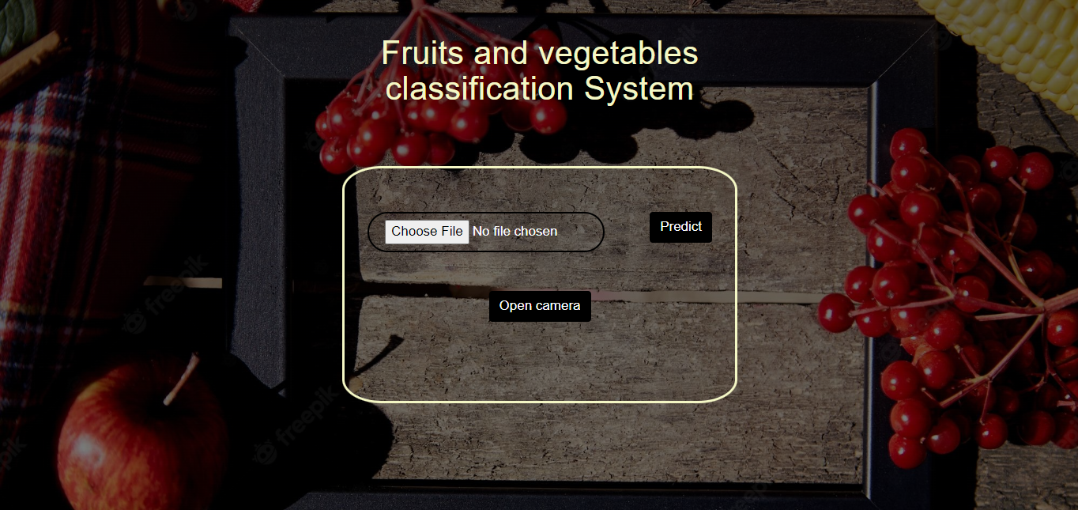

Step 2: select image

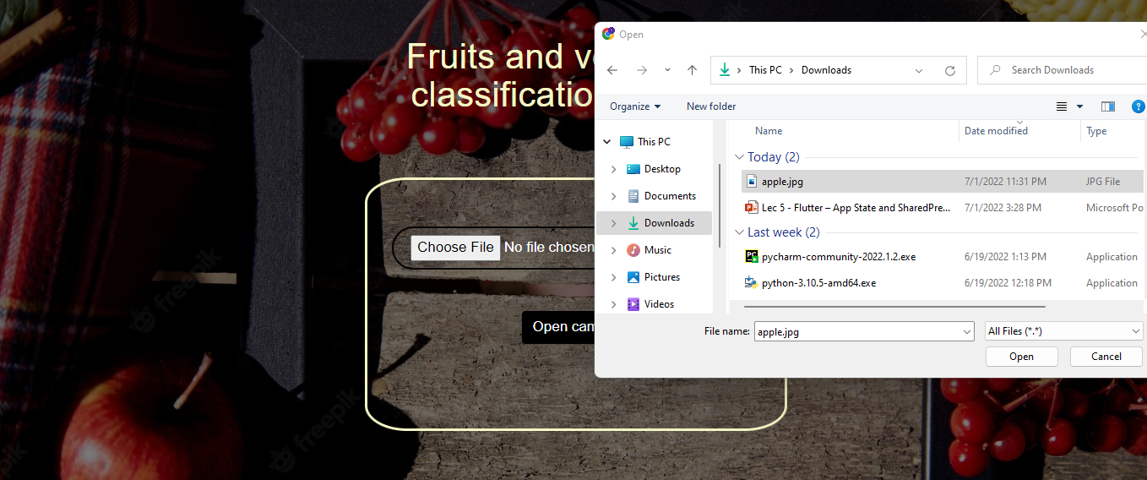

Step 3: Predict

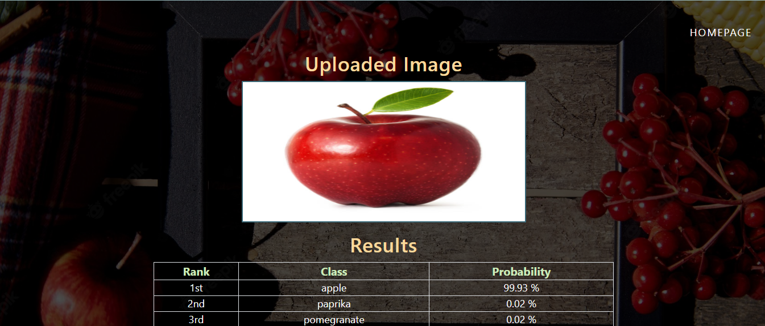

Method 2: Use Webcam

Step 1: Open camera

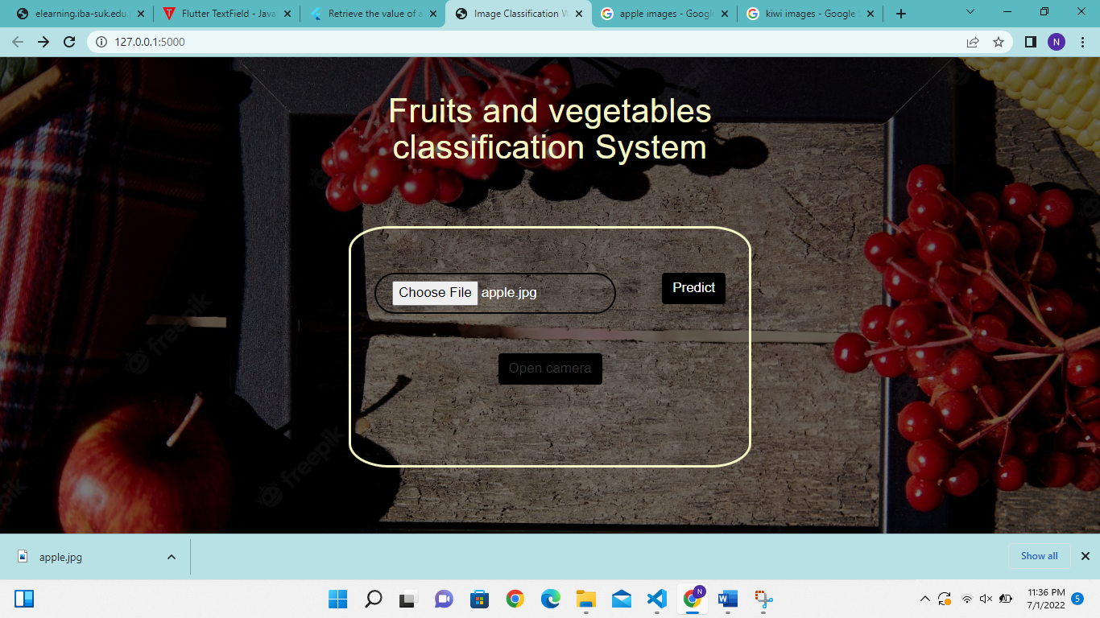

Step 2: click photo

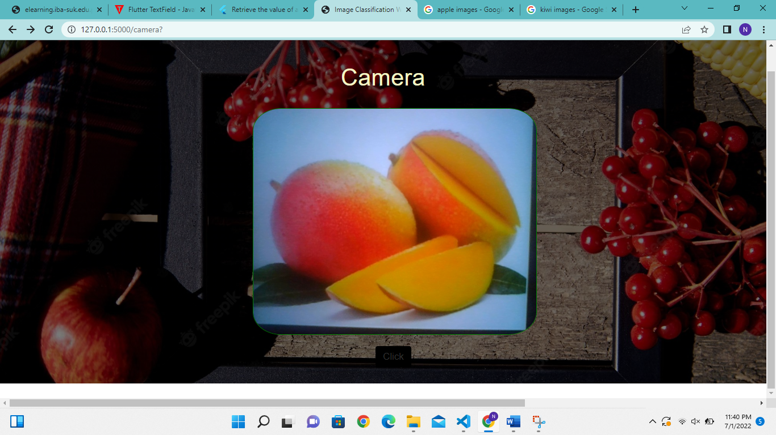

Step 3: predict

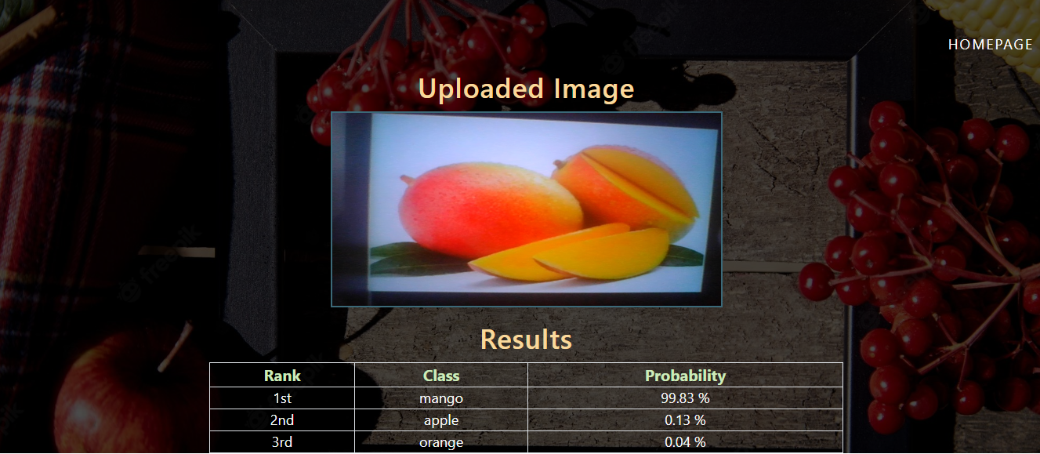

# **7.0 Project Timeline:**

|  |  |  |  |  |
| --- | --- | --- | --- | --- |
|  | May 10-15 | June 01-15 | June 15-25 | June 25 onwards |
| Proposal and idea |  |  |  |  |
| Model development and testing |  |  |  |  |
| Web implementation and deployment |  |  |  |  |
| Project Demo |  |  |  |  |

Table : Project timeline

# 

# **8.0 Conclusion:**

This project mainly recognizes the fruits and vegetables through shape, color, size and texture and reduces human efforts in identifying different types of fruits and vegetables. The web application provides great assistance and ease to the users to get benefit of this model. This project can be a source of motivation for future work in this field such as fruits and vegetables quality checking, fruits and vegetable disease detection and quality detection which can be great addition to machine learning in this field.

# **References**

|  |  |
| --- | --- |
| [1] | "HARVARD T.H.CHAN School of public Health," The Nutrition Source , [Online]. Available: https://www.hsph.harvard.edu/nutritionsource/what-should-you-eat/vegetables-and-fruits/. |
| [2] | "Saber Health care group," [Online]. Available: https://www.saberhealth.com/news/blog/benefits-of-fruits-and-vegetables. |
| [3] | C. C. Ukwuoma, Z. Q. B. H. M. B. A. L. A. Z. and M. H. N. , "Recent Advancements in Fruit Detection and Classification Using Deep Learning Techniques," *Mathematical Problems in Engineering,* 2022. |
| [4] | M. P. a. S. Kim, "A review of deep learning in image recognition," *2017 4th International Conference on Computer Applications and Information Processing Technology (CAIPT) ,* pp. 1-3, 2017. |
| [5] | "Udacity," [Online]. Available: https://www.udacity.com/course/intro-to-machine-learning--ud120. |
| [6] | M. M. R. M. D. Ms. Anisha M Nayak, "Fruit Recognition using Image Processing," *INTERNATIONAL JOURNAL OF ENGINEERING RESEARCH & TECHNOLOGY (IJERT) RTESIT,* 2019. |